**Windows LOGS**

1. List the users and external IP addresses that have failed to log in to the Exchange machine security logs in the last 15 minutes.

**index="wineventlog" EventCode=4625 Host=CNLEX01**

**| stats values(src_ip) count by user**

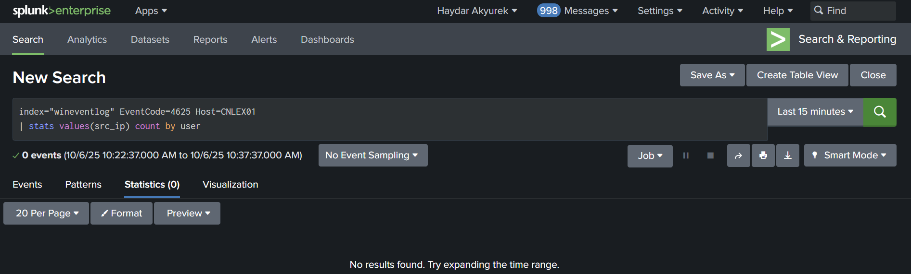

**2.** List users who have unsuccessfully logged in with more than one external IP address in the Exchange machine security logs in the last 15 minutes.

**index="wineventlog" EventCode=4625 Host=CNLEX01**

**| stats dc(src_ip) as gelen values(src_ip) as ip_list by user**

**| where gelen > 1**

**| table user gelen ip_list**

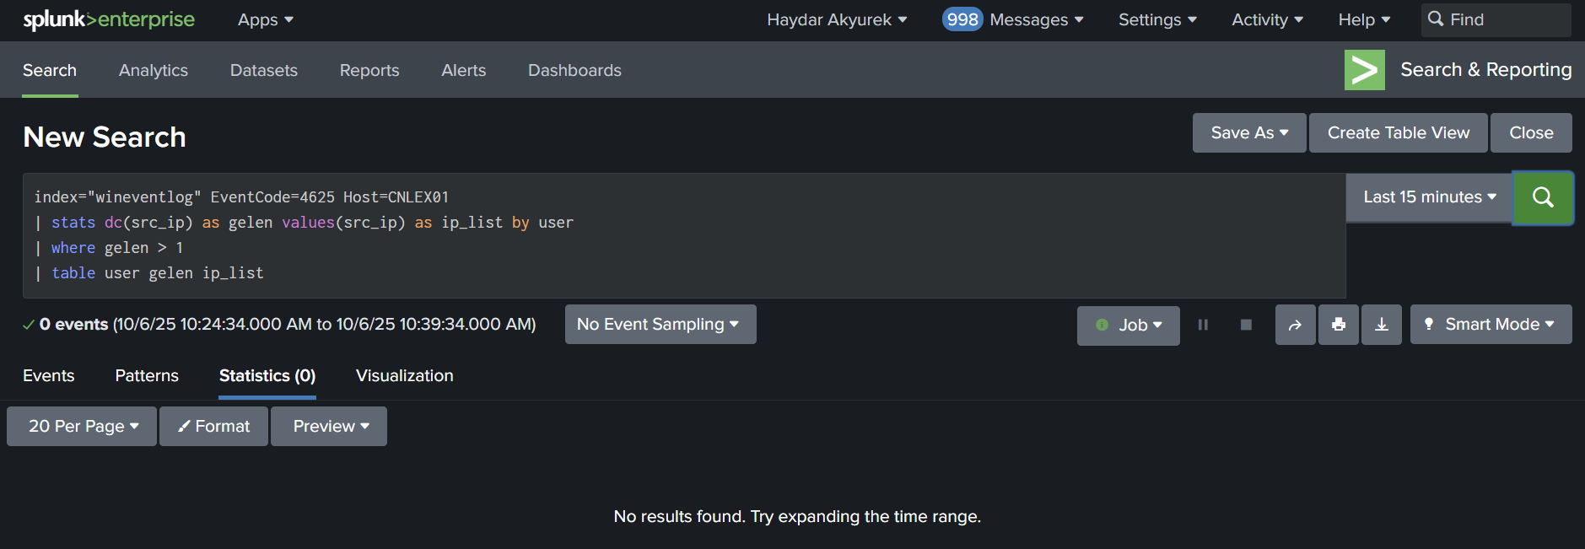

**3.** List successful and unsuccessful logins from the same user in the Windows security logs in the last 15 minutes.

**index=wineventlog EventCode=4624 OR EventCode=4625 user!=*$* | stats dc(user) by user**

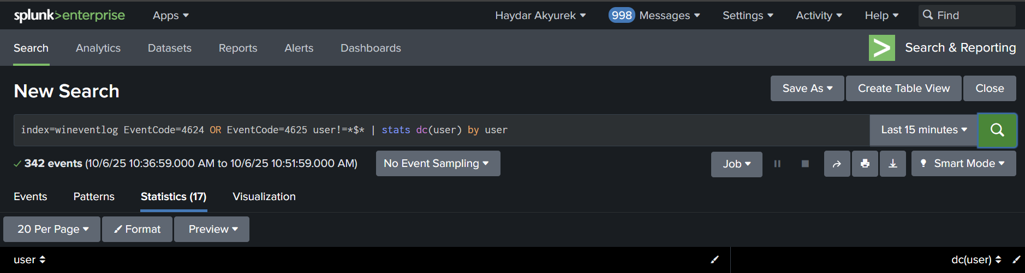

**4.** List users whose accounts have been locked in the Windows security logs in the last 24 hours.

**index="wineventlog" EventCode=4740 | table user| dedup user**

